**Task 5**

**The Colleague**

**Group:**

Kyle Bostelman – Full Jared Perry - Full Andrew Dzierla - Full Jeffrey Kimmel –Full

Brett Galloway – Full

**Application Revised:**

We revisited the application format and layout to slightly tweak it to fit the user better. The application color scheme is changeable once the user logs in making the colors anything the user chooses. This will eliminate the problem the user would have with the application. We feel as if we should stick with the school logo and color scheme to link the application with the college entity. Making the format and layout dull and less appealing for the majority of users. Although not all of the menu items the application possess is showed in the demo, the options would exist in the final model. Although one user found that the menus were difficult to reach, after a few minutes the user was easily able to figure out how the menus would be opened. This suggests that the learning curve may have been slightly more intense for this user, but the majority didn’t have any issues. We are afraid that changing the setup of the application would reduce the standardization and familiarity of the application. For this reason we would simply improve the emphasis on accessing these features in the introduction to the application. The hamburger menu was revised to apply more options to easily access important functions of the application. This will increase the user’s ability to utilize the application for the purpose of meeting people. Our prototype has been revised to show changes that the review the test users gave us showed. A finger depressing the buttons better shows actions of using the application.



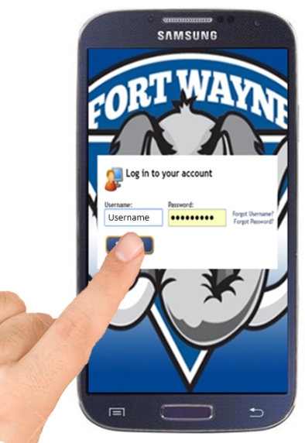

**Login Screen:** The user logs into their account using this familiar format. The menu allows the user to also select forgot username and forgot password. This will redirect the user to the school’s website to complete these functions.



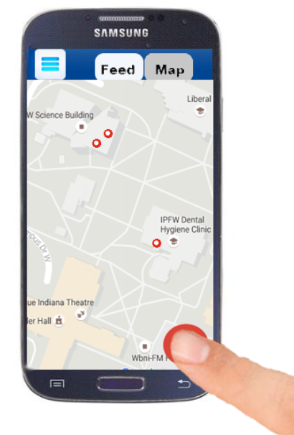

**Map View:** The user has the map button on the top toolbar depressed. The red dots represent meetings, and the ‘+’ button is the option to add a meeting.



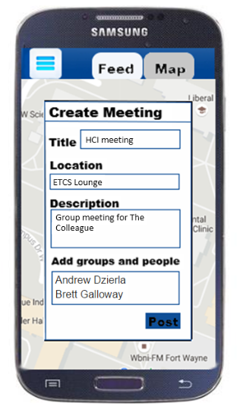

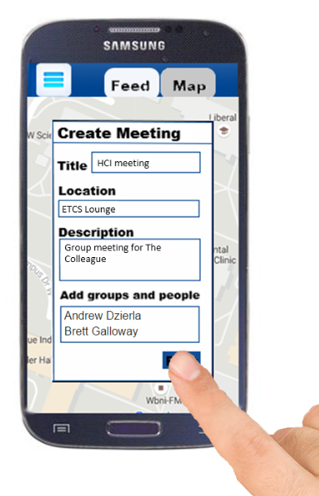

**Create Meeting Window:** The user can add a meeting by supplying the title of the meeting, the location, the description, and the users and groups the meeting should be associated with.

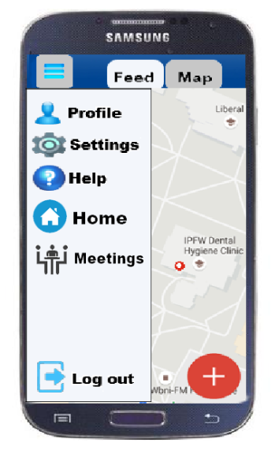

**Hamburger Menu:** A view that shows the options of profile settings, application settings, a help option, and an option to log out to the login screen.

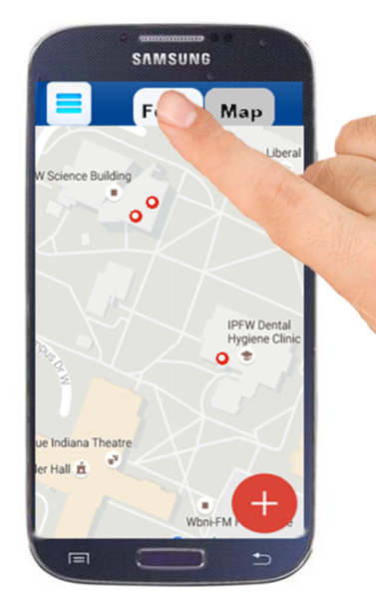



**Feed View:** Displays all personal meetings and group posts under the personal header. Shows all needs help tutor meetings, which are related to the user’s personal interests. Also, shows a general feed with college meetings and postings.